Mach 3 Flow Over Wedge
Example 2 in Compressible Flow Book, p. 168-169
DELSCA = 2*h_{min}, epslam = 0.01, csafe = 0.05, NITER = 10,000
Initial Mesh (NELEM = 3150, NPOIN = 1656, NBOUN =160)
(h_{avg} = 0.03)
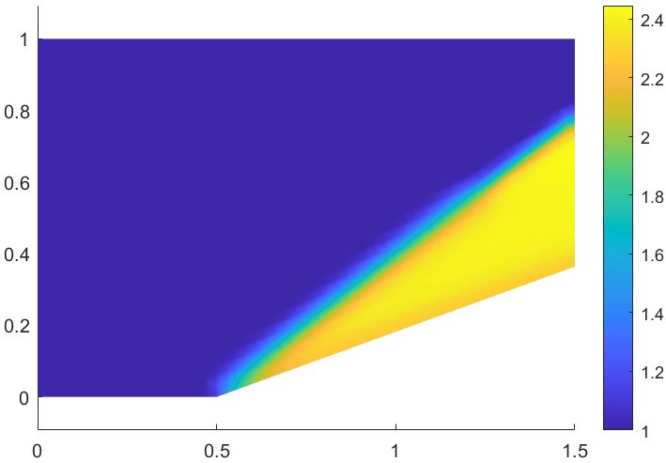
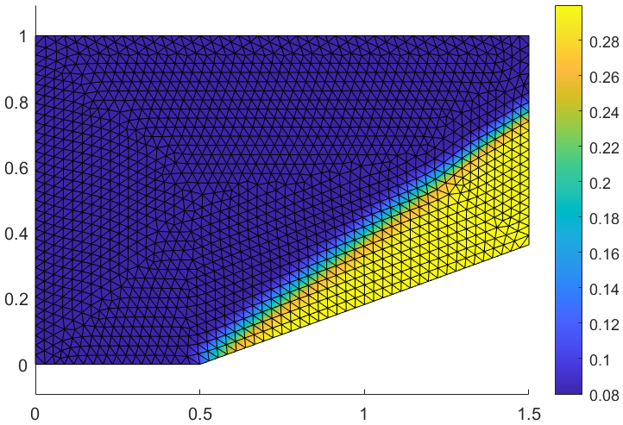
First Adaptive Mesh (NELEM = 712, NPOIN = 394, NBOUN = 74)
(h_{max} = 0.07, h_{min} = 0.02, S_{max} = 2.0)

Second Adaptive Mesh (NELEM = 882, NPOIN = 475, NBOUN = 66)
(h_{max} = 0.14, h_{min} = 0.01, S_{max} = 3.0)
Third Adaptive Mesh (NELEM = 1315, NPOIN = 696, NBOUN = 75)
(h_{max} = 0.2, h_{min} = 0.01, S_{max} = 4.0)

